Citizenship, Economics and Society (Secondary 1-3)
“3-minute Concept” Animated Video Clips Series:
“Triangular Theory of Love”
Teaching Guidelines

1. Title of the animated video clip: “Triangular Theory of Love”
2. Duration of the animated video clip: Around 3 minutes
3. Related CES module: Module3.1 Intimate Relationships with Affection and Propriety
4. Introduction of the animated video clip: The animated video clip was developed by the Personal, Social and Humanities Education Section, Curriculum Development Institute, Education Bureau. It uses daily examples and simple language to succinctly explain the concept of “Triangular Theory of Love”.
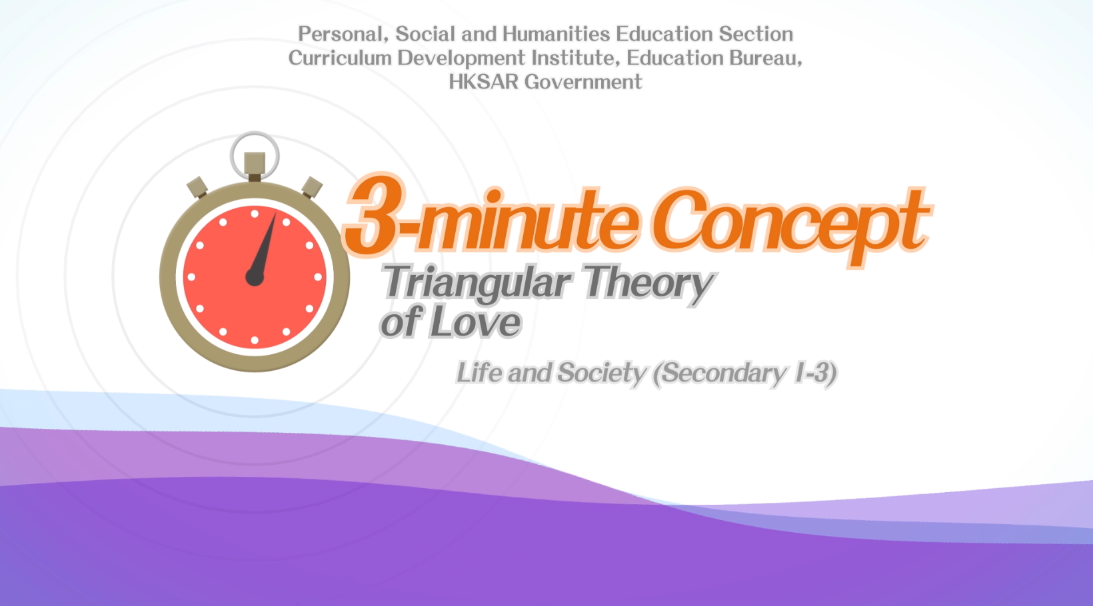
Citizenship, Economics and Society (Secondary 1-3)
Video link:
https://emm.edcity.hk/media/Life+and+Society+%223-minute+Concept%22+Animated+Video+Clips+SeriesA+%282%29+Triangular+Theory+of+Love+%28English+subtitles+available%29/1_0sk332jc
5. Teaching tips: Teachers must explain the following main points to students after playing the“Triangular Theory of Love” animated video clip:
1) Mutual respect is an important principle in the relationship between the two genders | Teachers should point out that when entering puberty, it is normal for students to be curious about the opposite sex and eager for love. Teachers should further point out to students that when getting along with the opposite sex, they must mutually respect each other, appreciate and learn from others’ strengths, respect others’ uniqueness, treat and accept others with sincerity, and must not say any insulting words or act in offensive behaviours.
2) Sex must be based on love with a solid foundation and commitment | - Teachers should emphasise to students that “sex” must be based on love with a solid foundation and commitment and that pre-marital sex should be rejected. Teachers should further point out that adolescents should gain more understanding of their partners’ personalities and characteristics when developing love relationships. They should work together to set limits of physical intimacy between themselves and should not engage in intimate behaviours rashly. As adolescents are still at the stage of physical and mental development and are not fully mature mentally, they should participate more in charity or group activities to learn more about themselves and explore their talents and those of others.
3) Sexual offences ordinances in relation to minors | Teachers should point out to students that there are laws  governing sexual offences in Hong Kong. Part XII of the Crimes Ordinance (Cap. 200) clearly sets out the laws on sexual and related offences, including sections 122, 123 and 124, etc, which deal with sexual offences relating to minors. Teachers should further point out to students that Hong Kong is a society governed by the rule of law and that students should understand and abide by the law. Teachers are suggested to refer to the following resource when explaining to students laws deal with sexual offences relating to minors:  Crimes Ordinance Part XII - Sexual and Related Offences  https://www.elegislation.gov.hk/hk/cap200!en?xpid=ID_1438402823098_004&INDEX_CS=N
4) Risks and consequences of unwed pregnancy and infection from sexually  transmitted diseases | - Teachers should point out to students that before engaging in sexual activities, both parties must clearly understand the possible risks and consequences, such as unwed pregnancy and infection from sexually transmitted diseases, and therefore should not act impulsively. Teachers should further point out to students that as adolescents are still receiving education at school, they lack the financial resources and the ability to raise children. Unwed pregnancy will significantly impact their families, academic studies and relationships with their partners.
5) Access credible information and seek professional support promptly | Teachers should point out to students that acquiring correct knowledge of gender relationships is essential for adolescents. Teachers should further point out to students that the Internet is full of inappropriate descriptions of gender relationships, which can easily lead to misunderstandings in adolescents. Students are advised to access credible information, such as the websites of the Department of Health, the Family Planning Association of Hong Kong, etc., to acquire the correct knowledge. Besides, if they feel uncertain when managing gender relationships, they should seek professional support from teachers and social workers.

6. Consolidation questions : (See next page)

“3-minute Concept” Animated Video Clips Series:

“Triangular Theory of Love”

Worksheet

A. Fill-in-the-blank Questions
Put the correct answers in the spaces provided.
American psychologist, Professor Sternberg, proposes the Triangular Theory of Love which states that love should be composed of three elements, including:
( Intimacy )
(is a feeling that makes people feel close and connected and bonded)
Consummate love
( Passion )
(is a feeling of intense emotion towards the person you like)
( Commitment )
(is the decision you make and the responsibility you take in order to nurture and maintain a love relationship)

B. True or False
Study the following sentences about “Triangular Theory of Love”. Put a “T” in the blank for correct description and an “F” for incorrect description.
 | “Romantic love” is a love relationship composed of “intimacy" and “passion”. | T
 | If people have sex on impulse, it may cause the risks of unwed pregnancy. | T
 | “Companionate love” is a love relationship mainly composed of “intimacy” and “commitment”. | F

C. Short Questions
How can we build a mature and healthy love relationship?
Only through a strong combination of the three components,
“intimacy”, “passion” and “commitment” can we build a mature
and healthy love relationship.

The End

